Two cops pulled off streets, Staten Island DA looking into death of dad of six after NYPD cop put him in chokehold during sidewalk takedown Friday, July 18, 2014, 12:02 PM

Officers Daniel Pantaleo and Justin Damico were both put on desk duty a day after the death of Eric Garner. Police Commissioner Bill Bratton and Mayor de Blasio, who has postponed his Italian vacation, promised a full investigation at a City Hall news conference.
A crisis over an unarmed man who died on a Staten Island street after a city cop grabbed him in a prohibited chokehold forced Mayor de Blasio to delay his Italian vacation Friday.
Officers Daniel Pantaleo, with eight years on the force, and Justin Damico, a four-year veteran cop, were both put on desk duty a day after the death of Eric Garner, Police Commissioner Bill Bratton said.
Garner’s arrest and desperate pleas that he couldn’t breathe were captured on an exclusive Daily News video that de Blasio admitted left him “with a heavy heart.”
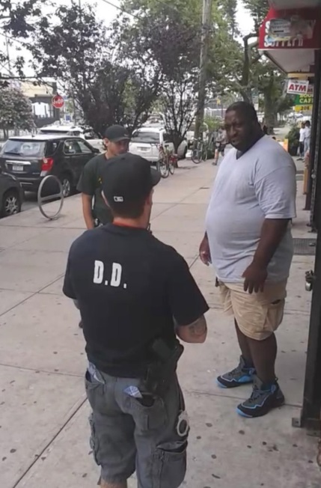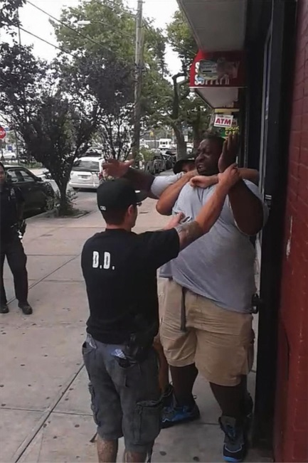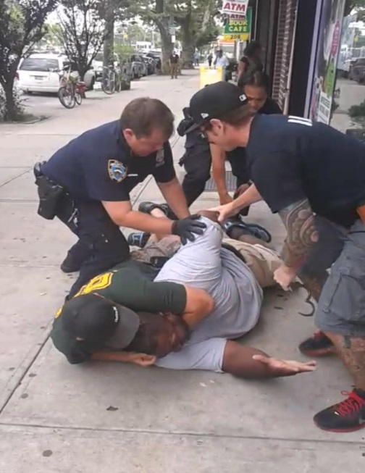
A 400-pound asthmatic Staten Island dad died Thursday after a cop put him in a chokehold and other officers appeared to slam his head against the sidewalk, according to video of the incident
Police officials said Garner has a history of arrests for selling untaxed cigarettes.
Video shows officers approaching Garner, who repeatedly insists he did nothing wrong.

'I can’t breathe! I can’t breathe!' Eric Garner repeatedly screamed after at least five NYPD officers took him down in front of a Tompkinsville beauty supply store when he resisted being handcuffed.
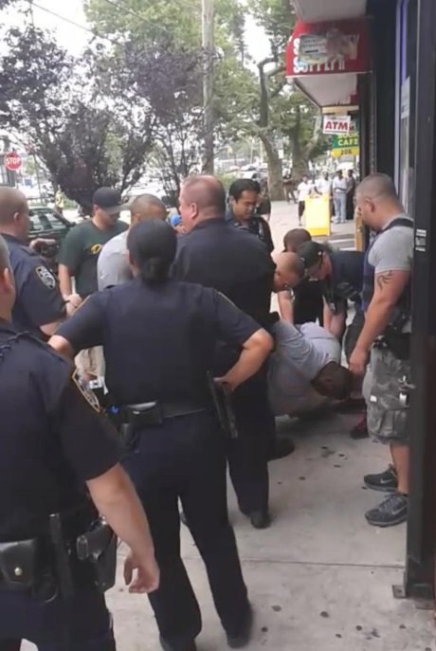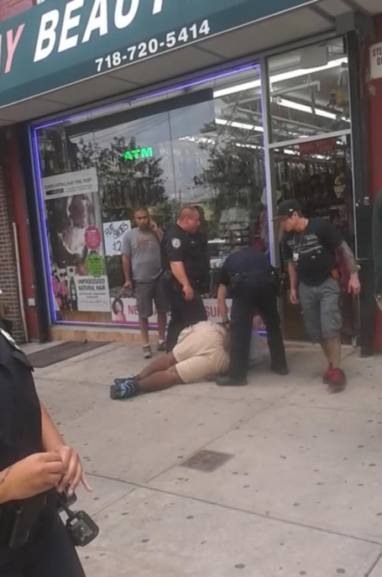
Within moments Garner, a married father of six children with two grandchildren, ceased struggling and appeared to become unconscious as police called paramedics to the scene.
It was very troubling,” he said at a City Hall news conference. “I watched it the same way a family member would watch it, and it was very sad to watch.”
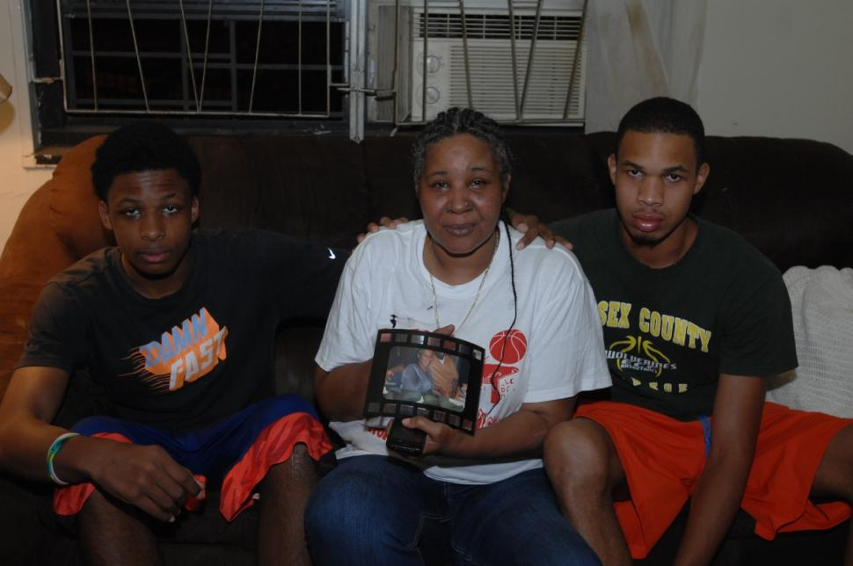
Hours later, the mayor put a hold on his vacation getaway. “He thought it was important to be here ... and consult with community leaders,” said a top aide. He and his family will instead leave Saturday
The Rev. Al Sharpton planned to host Garner’s family at his National Action Network headquarters in Harlem on Saturday morning.
Sharpton said the one-sided attack by five officers on the Garner was an outrage. “It’s the most inhumane, insensitive display of disregard for the citizens you’re supposed to protect that I’ve seen in a long time,” he said.
Pantaleo has been accused of false arrest and violating police procedures in two lawsuits, court records show. In one, two African-American plaintiffs won $15,000 apiece after claiming they’d been falsely arrested on Staten Island in 2012 and forced to publicly strip so cops could search them. All charges against them were dropped.
Plaintiff Darren Collins, 46, told The News on Friday night he was too frightened to talk.
“I’m scared of what (the cops) may do to me ... I was harassed” after the arrest, he said.
The other lawsuit, filed in Brooklyn in February, alleged Pantaleo trumped up charges to arrest the plaintiff, who was wrongly jailed for a day.
The Staten Island district attorney and the NYPD’s Internal Affairs Bureau were investigating Thursday’s death. Cops accused Garner of selling “loosies” — single cigarettes from packs without tax stamps.
The 43-year-old dad, whose rap sheet lists 31 arrests beginning when he was 16, had three full packs of cigarettes and one open pack of untaxed smokes when cops moved in, police said.
The loss of a life is always a tragedy,” said Bratton. “Nobody began the day with the expectation it would end the way it did.”
A video shot by a bystander captured Garner’s desperate cries as one cop shoved his head into the sidewalk and three others pinned him down — while a fifth cuffed him. “I can’t breathe!” he shouted in vain.
SOURCE: Read more: http://www.nydailynews.com/new-york/nyc-crime/staten-island-da-man-death-nypd-chokehold-article-1.1871946#ixzz38hMGta3N

